NYC MOTOR VEHICLE COLLISION ANALYSIS REPORT

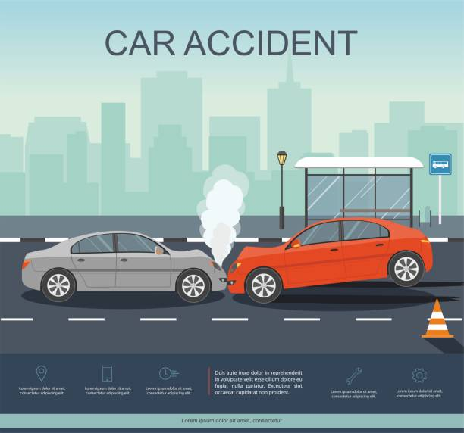

ACTIONS
I checked for missing values and found Street Name, Cross Street, Latitude and Longitude containing missing values.
For questions 1–4, these missing coordinates do not materially affect the analysis but they were properly cleaned.

Visualization and Analysis
[Image]

Question 1
Compare the % of Total Accidents by Month. Do you Notice Any Seasonal Patterns?

The highest Accident Month is March and the lowest Accident Month is December
In the case of seasonal patterns a noticeable pattern exists:
* Accident frequency is highest during the first quarter of the year (January–March).
* Accidents gradually decline toward the end of the year.
* March appears to be a peak collision month.
This suggests seasonal driving conditions, traffic volume, or weather-related factors may contribute to increased accident frequency early in the year.

Question 2
Break Down Accident Frequency by Day of Week and Hour of Day

Accidents by Day of Week
The most Accident-Prone Day is Friday (37,496 accidents) with the least Accident-Prone Day being Sunday (31,201 accidents).

Accidents by Hour
Peak Hour of accident is 4:00 PM (16:00)
Total collisions during this hour: 15,065 accidents
Findings
Accidents occur most frequently during afternoon rush hour which is approximately 4 PM – 6 PM
This aligns with commuter traffic congestion.

Question 3
On Which Street Were the Most Accidents Reported?

The most Dangerous Street is Belt Parkway with the number of Accidents at 3,728
Although Belt Parkway recorded the highest number of collisions, it still represents only 1.56% of all reported accidents, indicating collisions are widely distributed throughout New York City.

Question 4
What is the most common contributing factor for the accidents based on Vehicle 1

Findings
The most reported factor overall is ‘Unspecified’, however, this is not actionable.
The most meaningful contributing factor which is the next In line is Driver Inattention/Distraction with 58,308 accidents.
This strongly suggests distracted driving is a major road safety issue.

Fatal Accidents Specifically
Top Fatal Contributing Factors includes
- Unspecified
- Unsafe speed
- Driver Inattention/Distraction
- Failure to Yield Right of Way
- Traffic Control Disregarded
Findings
Ignoring "Unspecified", Unsafe Speed is the leading known cause of fatal accidents.
This indicates speeding contributes disproportionately to severe crashes and fatalities.

Additional Insights
Insight 1: Brooklyn Has the Highest Accident Count and accounts for the highest collision volume and should be prioritized for traffic safety interventions.

Insight 2: Injury Rate
Accidents involving at least one injury = 36.53%
This means more than one-third of all collisions resulted in injuries.

Insight 3: Fatality Rate
Accidents involving at least one death = 0.257%
Although fatalities are relatively rare, the consequences are severe.

Insight 4: Human Behavior Is the Main Problem
The leading actionable causes include:
* Driver Inattention/Distraction
* Unsafe Speed
* Failure to Yield Right-of-Way
These are driver-behavior issues rather than road infrastructure issues.

Recommendations
1. Strengthen Distracted Driving Enforcement
* Increase enforcement of phone-use laws.
* Expand public awareness campaigns.

2. Target Speeding Hotspots
* Install speed cameras.
* Increase patrol presence on high-risk corridors.

3. Focus Resources on Friday Rush Hours
Since accidents peak on Fridays around 4 PM, targeted traffic management during these periods could significantly reduce collisions.

4. Prioritize Brooklyn and Belt Parkway
Deploy traffic safety initiatives in areas with the highest accident concentrations.

Conclusion
The analysis shows that collisions in New York City are primarily driven by driver behavior, particularly distraction and speeding.
Accidents are most common during Friday afternoon rush hours, while Belt Parkway is the single street with the highest collision count.
To reduce accidents and fatalities, policymakers should focus on distracted driving, speeding enforcement, and targeted interventions in high-risk locations and time periods.

